Linear Programming Using EXCEL Solver (EXCEL Solver is an EXCEL add-in)

EXCEL2010: Click on the File tab, then select “Options”, “Add-ins”, select “Solver Ad-in” from the list on the right. Click “Go”, make sure “Solver Add-in’ is checked, then OK.

EXCEL2007: Click on the Windows Logo in the upper left. Click on ‘Excel Options’ at the bottom. Select ‘Add-Ins’, then’Solver’. Click ‘GO”. Check the ‘Solver’ add-in, then ‘OK’. Solver will be in the Analysis tab (look on the far right if necessary).

EXCEL2003: To install the Solver, choose Add-Ins from the Tools menu. Then select Solver Add-In from the resulting Add-Ins dialog box.

We will solve the following problems using Solver.

Example 1:
Suppose a company manufactures two products, A and B, which can be sold for $120 per unit and $80 per unit respectively. Management requires that at least 1000 units be manufactured each month. Product A requires five hours of labor per unit, and product B requires three hours per unit. The cost of labor is $12 per hour, and a total of 8000 hours are available per month. Determine a monthly production schedule that will maximize the company’s profit.

Here is the set-up to the problem.

Definitions of variables: Let x = the number of units of product A manufactured per month
y = “ “ “ “ “ “ B “ “ “

Objective function: Maximize P (profit) = (120 – 5*12)x + (80 – 3*12)y = 60x + 44y

Non-negative constraint: x, y > 0

Problem constraints: x + y > 1000 units manufactured per month
5x + 3y < 8000 labor hours available per month

Enter the above set-up in EXCEL as follows.
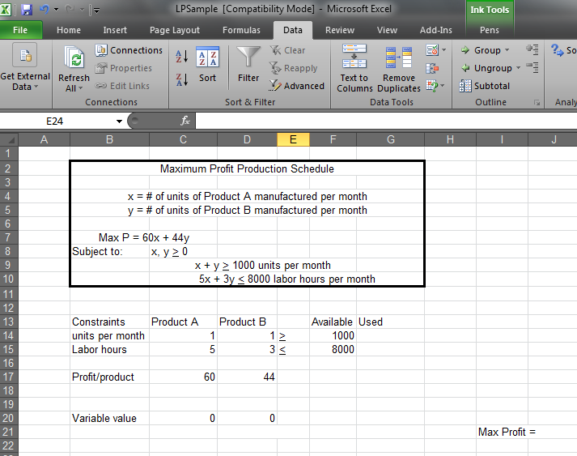
Now you will enter formulas under “Used” and next to “Max Profit”. See below. The formula is displayed next to the appropriate cell (this is to help you know what formula to enter in the cells to the left).
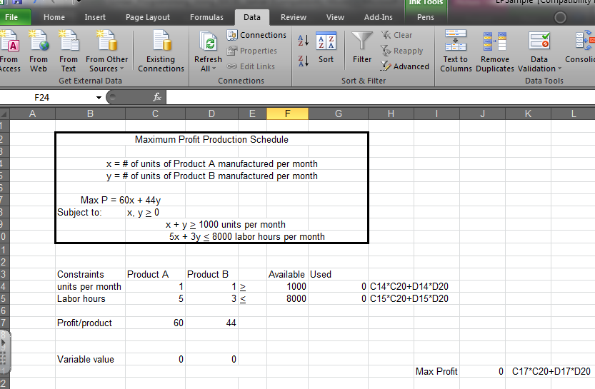

Next, click on the "Data" tab and select "Solver". The target cell will be the location of your objective function (currently a value of 0).
"By changing cells" are the variable cells currently having values of 0.
The constraints will be each of the "actual used" cells (initially 0), inequality sign, corresponding "available" cell
The non-negative constraints will be each variable >= 0. (You can check the box in front of ‘Make Unconstrained
Variables Non-Negative’.)

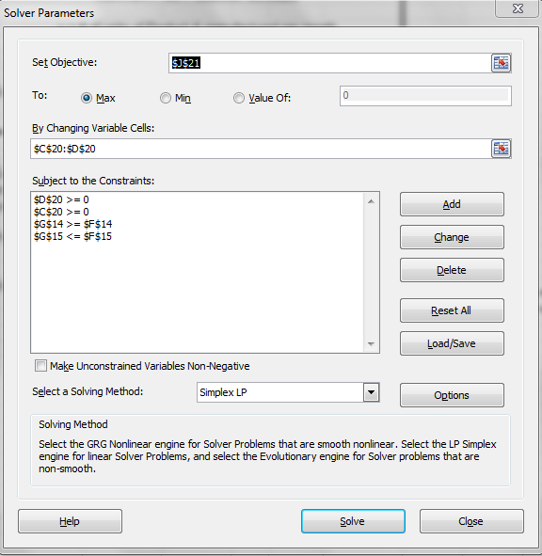
Click "Solve". Before clicking "OK", select (highlight) "Answer" under Reports. Click "OK".
The problem will be solved (if possible), and the Answer Report will be on an additional page.
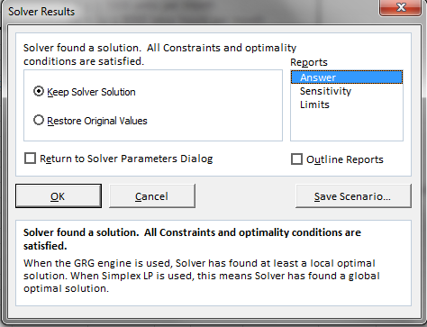

Microsoft Excel 10.0 Answer Report
Worksheet: [LPSample.xls]Sheet1
Report Created: 10/12/2005 6:06:43 PM
Target Cell (Max)
 | Cell | Name | Original Value | Final Value
 | $J$21 | Max Profit = | 0 | 117333.3333
Adjustable Cells
 | Cell | Name | Original Value | Final Value
 | $C$20 | Variable value Product A | 0 | 0
 | $D$20 | Variable value Product B | 0 | 2666.666667
Constraints
 | Cell | Name | Cell Value | Formula | Status | Slack
 | $G$14 | > Used | 2666.666667 | $G$14>=$F$14 | Not Binding | 1666.666667
 | $G$15 | < Used | 8000 | $G$15<=$F$15 | Binding | 0
 | $C$20 | Variable value Product A | 0 | $C$20>=0 | Binding | 0
 | $D$20 | Variable value Product B | 2666.666667 | $D$20>=0 | Not Binding | 2666.666667

Second example: A company manufactures chairs, sofas, and loveseats. Each product will need to spend time in the carpentry, finishing, and upholstery divisions. The chart below summarizes the amount of time (in hours) required for each product in each division.

Process  Carpentry  Finishing  Upholstery | Chair | Sofa | Loveseat
Process  Carpentry  Finishing  Upholstery | 6 | 3 | 2
Process  Carpentry  Finishing  Upholstery | 1 | 1 | 1
Process  Carpentry  Finishing  Upholstery | 2 | 6 | 4
Each chair makes a profit of $80, each sofa makes a profit of $70, and each loveseat makes a profit of $66. How many chairs, sofas, and loveseats must be manufactured to maximize profit if there are 96 hours available for carpentry, 18 hours for finishing, and 72 for upholstery?

Setup: Definitions: x = the # of chairs, y = the # of sofas, z = the # of loveseats.
Maximize P = 80x + 70y + 66z
Subject to: x, y, z, > 0
6x + 3y + 2z < 96 carpentry hours
x + y + z < 18 finishing hours
2x + 6y + 4z < 72 upholstery hours

Setup in EXCEL
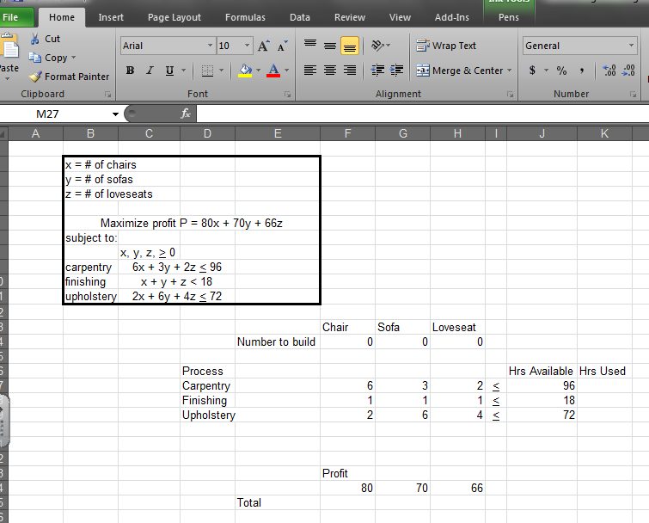
Now add formulas for each constraint and the total profit. The formulas are shown next to the cells that contain them.
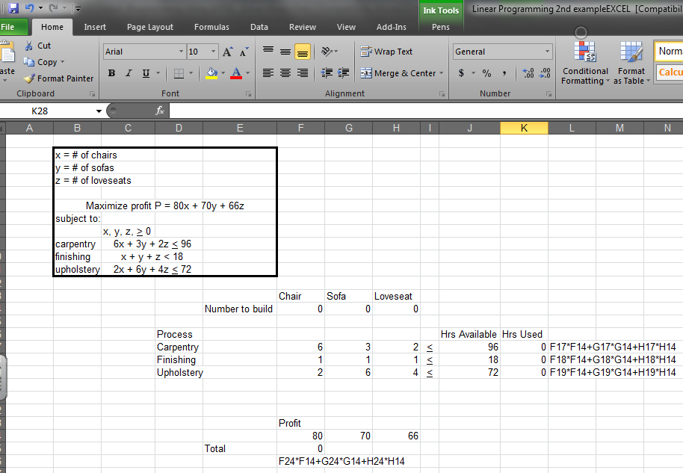

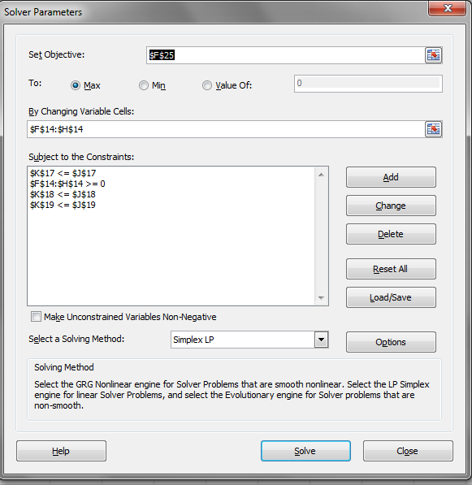
Repeat the steps below:
Next, click on the "Data" tab and select "Solver". The target cell will be the location of your objective function (currently a value of 0).
"By changing cells" are the variable cells currently having values of 0.
The constraints will be each of the "actual used" cells (initially 0), inequality sign, corresponding "available" cell
The non-negative constraints will be each variable >= 0. (You can check the box in front of ‘Make Unconstrained Variables Non-Negative’.)

Click "Solve". Before clicking "OK", select (highlight) "Answer" under Reports. Click "OK".
The problem will be solved (if possible), and the Answer Report will be on an additional page.
